 

**SMART SATELLITE SYSTEM: ENHANCING WEATHER FORECASTING AND AIR QUALITY MONITORING WITH INTEGRATED APP CONNECTIVITY**

**A MINI PROJECT REPORT**

***Submitted by***

**AJIN RIBIA P (727722EUEC011)**

**ASHIKASRI C K (727722EUEC024)**

**DHARSHINI M (727722EUEC040)**

***in partial fulfillment for the award of the degree***

***of***

**BACHELOR OF ENGINEERING**

**IN**

ELECTRONICS AND COMMUNICATION ENGINEERING

**SRI KRISHNA COLLEGE OF ENGINEERING AND TECHNOLOGY**

**(An Autonomous Institution, Affiliated to Anna University Chennai - 600 025)**

MAY 2024



**BONAFIDE CERTIFICATE**

Certified that the mini project report “**SMART SATELLITE SYSTEM: ENHANCING WEATHER FORECASTING AND AIR QUALITY MONITORING WITH INTEGRATED APP CONNECTIVITY”** is the bonafide work of **“AJIN RIBIA P (727722EUEC011), ASHIKASRI C K(727722EUEC024), DHARSHINI M (727722EUEC040)”** who carried out theproject work under my supervision.

|  |  |
| --- | --- |
| **SIGNATURE Dr.S. SASIPRIYA, M.E., Ph.D.,**  **HEAD.OF.THE.DEPARTMENT**  Department.of_Electronics_and Communication Engineering,  Sri Krishna College of Engineering  and Technology, Coimbatore-641008 | **SIGNATURE**  **Ms.VANITHA.U,_MTech.,Ph.D., SUPERVISOR**  **ASSISTANT PROFESSOR**  Department.of.Electronics.and-  Communication Engineering,  Sri Krishna College of Engineering  and Technology, Coimbatore-641008 |

This project report submitted for the Autonomous mini-project Viva–voce examination held on __________

|  |
| --- |
| INTERNAL EXAMINER EXTERNAL EXAMINER |

**ABSTRACT**

This paper proposes the development of a Smart Satellite System aimed at enhancing weather forecasting and air quality monitoring through integrated app connectivity. Weather monitoring systems allow certain weather conditions and air quality to be predicted before they come in phase. This system allows users to gain access to these systems virtually without the necessity of physically being at the location. The system senses the climatic conditions with weather sensors by studying its patterns and giving a more accurate prediction. It senses data wirelessly over a given distance where the outcome is shown on an LCD screen, and transmits the results to a GSM module. It can detect various weather conditions and air quality using different sensors that work together by interfacing them on the microcontroller, thereby, allowing a single weather monitoring station to be able to sense various weather conditions and reducing the cost of constructing a weather monitoring station that can analyze only a particular type of weather condition. The Smart Satellite System aims to improve forecasting accuracy, enhance air quality monitoring, and increase resilience to the impacts of climate change.

**Key words:**

**Smart Satellite System, Weather Forecasting, Air Quality Monitoring.**

**TABLE OF CONTENTS**

|  |  |  |
| --- | --- | --- |
| **CHAPTER NO** | **TITLE** | **PAGE NO** |
|  | **ABSTRACT**  **LIST OF FIGURES** | **iii**  **vii** |
| **1** | **INTRODUCTION** | **1** |
|  | * 1. BASIC PRINCIPLE   1.2 AREA OF PROJECT | 1  2 |
| **2** | **LITERATURE SURVEY** | **4** |
|  | 2.1 AIR QUALITY MONITORING SYSTEM BASED ON ISO/IEC/IEEE 21451 STANDARDS2.2 IOT BASED AIR QUALITY AND WEATHER MONITORING SYSTEM WITH ANDROID APPLICATION 2.3 DEVELOPMENT OF A COST-EFFECTIVE IOT BASED WEATHER MONITORING SYSTEM  2.4 IOT BASED DATA LOGGER SYSTEM FOR WEATHER MONITORING USING WIRELESS SENSOR NETWORKS IOT BASED URBAN CLIMATE MONITORING USING RASPBERRY PI  2.5 WIRELESS SENSOR NETWORK BASED POLLUTION MONITORING SYSTEM IN METROPOLITAN CITIES | 4  5  6  7  8 |
| **3** | **CIRCUIT DIAGRAM AND WORKING** | **10** |
|  | 3.1 PROTOTYPE  3.2 WORKING  3.3 ADVANTAGES | 10  11  15 |
| **4** | **COMPONENT DESCRIPTION** | **16** |
|  | 4.1 PCB BOARD  4.2 RASPERRY PI PICO  4.3 MQ -2 SENSOR  4.4 BMP-280 SENSOR  4.5 I2 C  4.6 MPU 6050 SENSOR  4.7 MICROSD CARD  4.8 SIMULATION TOOL -THONNY | 16  17  19  20  21  22  23  23 |
| **5** | **CONCLUSION AND FUTURE SCOPE** | **25** |
|  | 5.1 CONCLUSION  5.2 FUTURE SCOPE | 25  25 |
| **6** | **RESULT**  APPENDIX  REFERENCES | **26**  27  34 |

**LIST OF FIGURES**

|  |  |  |
| --- | --- | --- |
| **FIGURE NO** | **TITLE** | **PAGE NO** |
| 1.1 | FLOW CHART | 2 |
| 3.1 | PROTOTYPE AT INITIAL STAGE | 10 |
| 3.2 | OUTPUT AT INITIAL STAGE | 10 |
| 3.3 | PROTOTYPE AT SECOND STAGE | 12 |
| 3.4 | OUTPUT AT SECOND STAGE | 12 |
| 3.5 | PROTOTYPE AT THIRD STAGE | 12 |
| 3.6 | OUTPUT AT THIRD STAGE | 12 |
| 3.7 | FINAL STAGE | 14 |
| 3.8 | FINAL OUTPUT | 14 |
| 4.1 | PCB BOARD | 16 |
| 4.2 | RASPBERRY PI PICO | 17 |
| 4.3 | MQ-2 SENSOR | 19 |
| 4.4 | BMP 280 SENSOR | 20 |
| 4.5 | MPU-6050 SENSOR | 21 |
| 4.6 | MICROSD CARD | 22 |
| 4.7 | THONNY | 24 |

**CHAPTER 1**

**INTRODUCTION**

* 1. **BASIC PRINCIPLE**

The basic principle of a Smart Satellite System aimed at enhancing weather forecasting and air quality monitoring can be realized by integrating Raspberry Pi Pico microcontrollers into the system architecture. Raspberry Pi Pico microcontrollers can be employed as data acquisition units onboard the satellite. Equipped with various sensors such as temperature, smoke detection, pressure, and gas sensors, the Pico can gather real-time environmental data in the particular location. These sensors can capture crucial parameters necessary for weather forecasting and air quality monitoring, ensuring a legit dataset.

Upon collecting data, the Raspberry Pi Pico processes and analyzes it onboard using its computational capabilities. It identifies temperature, pressure, humidity and assesses pollutant levels that may indicate environmental changes. Raspberry Pi Pico microcontrollers serve as communication hubs within the satellite system and transmit the data to the SD card.

Ground stations equipped with Raspberry Pi Pico units can receive, process, and store incoming data streams, enabling scientists and meteorologists to collaborate in refining weather forecasts and air quality assessments. By integrating with mobile applications, the Pico facilitates user access to real-time weather forecasts, air quality reports, and environmental data visualizations. This empowers individuals and communities to make informed decisions based on the insights provided by the Smart Satellite System.

By leveraging Raspberry Pi Pico microcontrollers within the Smart Satellite System, the basic principle of enhancing weather forecasting and air quality monitoring is realized through efficient data acquisition, processing, communication, and user interaction capabilities.

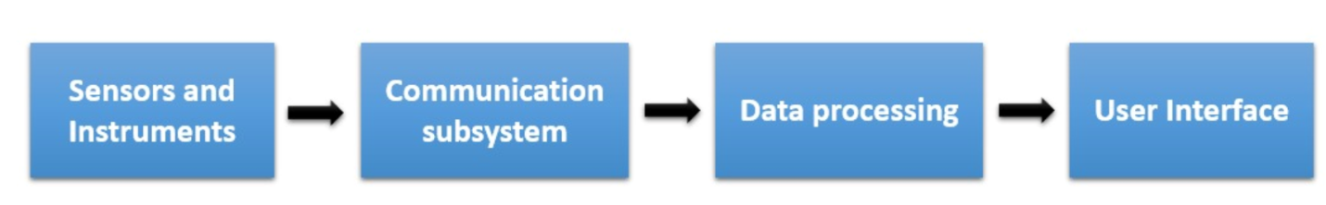

**Figure 1.1 Flow chart**

* 1. **AREA OF THE PROJECT:**

IoT and Embedded Systems

IoT refers to the network of physical devices, vehicles, appliances, and other items embedded with sensors, actuators, software, and connectivity, which enables them to connect and exchange data over the internet. Devices are equipped with sensors to collect data from the environment and actuators to perform actions based on received instructions.

Various wireless and wired technologies such as Wi-Fi, Bluetooth, Zigbee, and cellular networks enable communication between IoT devices and the internet. Data collected by IoT devices is processed locally or in the cloud, often utilizing big data analytics and machine learning algorithms to derive actionable insights. IoT applications provide users with interfaces to monitor and control connected devices, automate tasks, and receive alerts or notifications.

Embedded systems are specialized computing systems designed to perform specific functions or tasks within larger systems or devices. They are typically embedded into hardware components and operate with real-time constraints. Embedded systems are tailored to execute specific tasks efficiently, often with low power consumption and compact form factors. Embedded systems utilize microcontrollers or microprocessors as their computing cores, often integrated with memory, I/O interfaces, and other peripherals on a single chip.

Embedded systems may run specialized operating systems optimized for real-time performance, resource efficiency, and reliability. Software development kits (SDKs), compilers, debuggers, and integrated development environments (IDEs) are essential for designing, programming, and testing embedded systems.

**CHAPTER 2**

**LITERATURE SURVEY**

**EXISTING METHODOLOGIES:**

**2.1 Air quality monitoring system based on ISO/IEC/IEEE 21451 _______standards**

This project aims to monitor air quality in specific areas like the chemical industry near Pune and the IT area in Hinjewadi. It utilizes wireless sensors to measure harmful gases like CO2, CO, NO2, and SO2 in real-time. The system is built on IEEE/ISO/IEC 21451 standards, which ensure interoperability and reliability. It employs GSM wireless communication for data transmission, ensuring connectivity even in remote areas. The system evaluates various sensor technologies and opts for electrochemical and infrared sensors for their reliability and accuracy in measuring air pollutants. Both hardware and software components of the air quality monitoring system are designed and implemented. This includes the integration of sensors, communication modules, and a graphical user interface (GUI) for easy interaction. The system wirelessly transmits data from the sensors to the base station, where it can be processed and visualized on the GUI. This allows end-users to easily interpret air quality data in real-time. Regular calibration of the instruments ensures the accuracy of the measurements over time, maintaining the reliability of the system in providing precise air quality data. The system not only measures current air quality but also has the capability to forecast future pollution levels. It can send warning messages to specific polluted areas, enabling proactive measures to mitigate pollution. Overall, the described air quality monitoring system appears to be a comprehensive solution for monitoring and managing air pollution, particularly in industrial and urban environments. It integrates advanced sensor technologies with wireless communication and data visualization capabilities to provide accurate and timely information to stakeholders.

**2.2 IoT based Air Quality and Weather Monitoring System with Android Application**

This system increasing variability and unpredictability of weather and climatic conditions pose significant challenges to agricultural productivity. Having access to real-time weather information is crucial for farmers to make informed decisions about their crops. The Internet of Things (IoT) technology is being leveraged to develop a weather monitoring system. This system likely employs sensors to collect data on various environmental parameters such as air quality, precipitation, temperature, and humidity. The weather monitoring system is integrated with an Android application, allowing users to access weather data remotely via the internet. Additionally, a dedicated server is likely used to store and manage the collected weather data. The system is designed to be deployable anywhere, indicating its versatility and adaptability to different geographical locations and agricultural settings. The system includes external devices that can trigger alerts when pollution levels exceed safe thresholds. These alerts can be disseminated to people in affected areas via the Android application, enhancing awareness and potentially mitigating the impact of pollution on both agriculture and public health. This system aims to empower farmers to optimize their agricultural practices. This includes efficient utilization of agricultural inputs and timely interventions to address weather-related challenges, ultimately enhancing crop yields and agricultural sustainability. Overall, the proposed weather monitoring system demonstrates a commitment to leveraging technology to address the challenges posed by climate variability and environmental pollution in agriculture. It seeks to enhance the resilience of farmers by providing them with actionable information to manage their crops effectively.

**2.3 Development of a Cost-effective IoT-based Weather Monitoring System**

The main objective of this work is to develop and deploy a cost-effective IoT platform for monitoring and archiving weather data in a residential area. The focus is on collecting data related to temperature, humidity, atmospheric pressure, and dust particles. Open-source technologies are utilized for the development of this IoT platform. This choice likely reduces costs and provides flexibility for customization. The message queuing telemetry transport (MQTT) protocol is implemented for efficient communication between the IoT devices and the server. The IoT devices, including NodeMCU ESP 8266 and Raspberry Pi Zero W, are responsible for collecting weather data. This data is then sent to a remote virtual private server (VPS) over the Internet. A server application continuously collects and logs this data into a database for further analysis and archival. The necessary steps for setting up a VPS server, securing it, and installing the IoT server application are described. This ensures that the data transmission and storage processes are reliable, secure, and protected against potential cyber threats. The feasibility of the developed IoT platform is verified through real-time implementation using the specified IoT devices and sensors. This validates the proof-of-concept and demonstrates that the system can effectively collect, transmit, and archive weather data in a residential environment. The use of open-source technologies and scalable architecture allows for the rapid development and deployment of the weather station. This helps in achieving faster time-to-market while addressing privacy and safety concerns associated with the end product.

**2.4 IoT based Data Logger System for Weather_Monitoring using Wireless Sensor Networks IoT based Urban Climate Monitoring using Raspberry pi**

The system proposed in this paper is an advanced solution for monitoring the weather conditions at a particular place and make the information visible anywhere in the world. The technology behind this is Internet of Things (IoT), which is an advanced and efficient solution for connecting the things to the internet and to connect the entire world of things in a network. Here things might be whatever like electronic gadgets, sensors and automotive electronic equipment. The system deals with monitoring and controlling the environmental conditions like temperature, relative humidity, light intensity and CO2 level with sensors and sends the information to the web page and then plot the sensor data as graphical statistics. The data updated from the implemented system can be accessible in the internet from anywhere in the world. The importance of weather monitoring is existed in many aspects. The weather conditions are required to be monitored to maintain the healthy growth in crops and to ensure the safe working environment in industries, etc. Due to technological growth, the process of reading the environmental parameters became easier compared to the past days. The sensors are the miniaturized electronic devices used to measure the physical and environmental parameters.

**2.5 Wireless sensor network based pollution monitoring system in -------metropolitan cities**

The main objective of this study is to develop a model for detecting and monitoring air pollution. This is crucial for creating a better and safer environment for humans, animals, and plants. A sensor grid is utilized to detect sensor values from different gas sensors. These sensors likely measure various pollutants such as carbon monoxide (CO), nitrogen dioxide (NO2), sulfur dioxide (SO2), etc. A microcontroller is employed to transfer the sensor values from the analog-to-digital converter (ADC) to a server. This ensures that the data collected from the sensors is transmitted efficiently for further processing. Data mining algorithms are used to calculate the pollutants based on the sensor values. Specifically, the ID3 algorithm, a popular decision tree algorithm, is utilized to calculate the pollutant values based on probability. A Bluetooth module is employed to connect the microcontroller with the client device. The client then connects with the server via web services, enabling seamless communication between the sensor grid and the central monitoring system. By utilizing data mining algorithms and real-time data transmission, the model enables continuous monitoring of air pollution levels. This allows for timely interventions and corrective actions to mitigate pollution and safeguard environmental and public health. Overall, the proposed model represents an innovative approach to air pollution detection and monitoring, leveraging sensor technology, data mining algorithms, and communication protocols to create a comprehensive monitoring system. This system has the potential to contribute significantly to efforts aimed at controlling pollution and ensuring a healthier environment for all.

**CHAPTER 3**

**3. PROTOTYPE AND WORKING**

**3.1 PROTOTYPE**

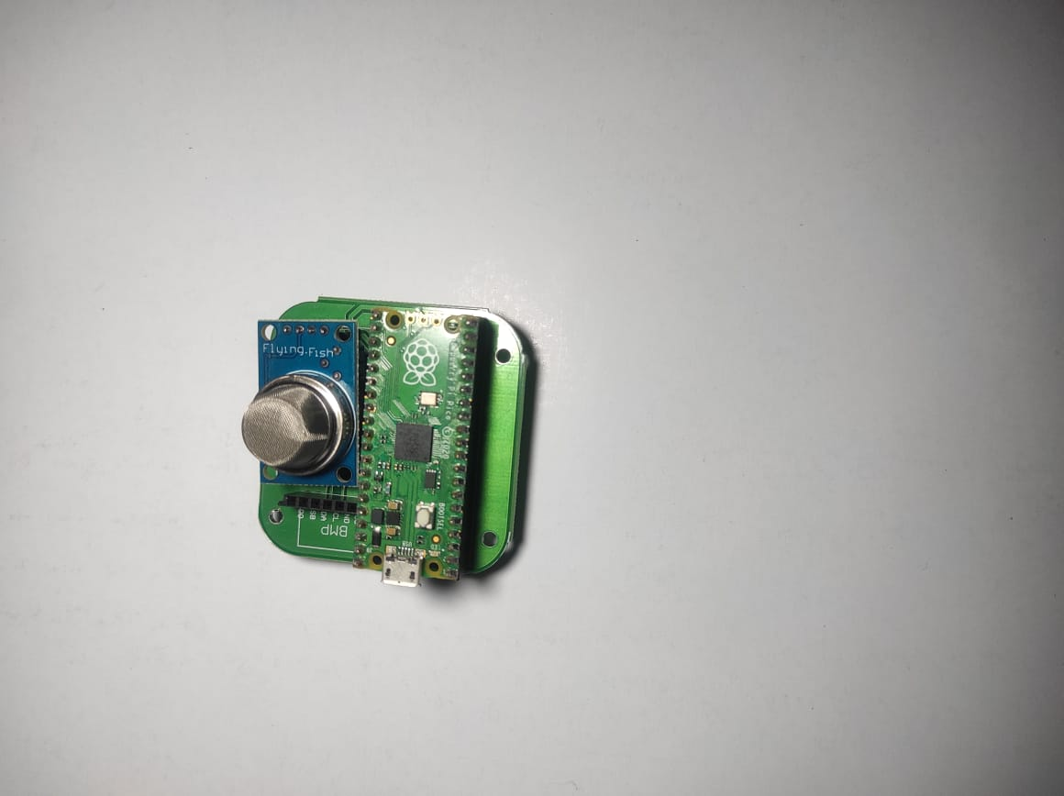

**Figure 3.1 PROTOTYPE AT INITIAL STAGE**

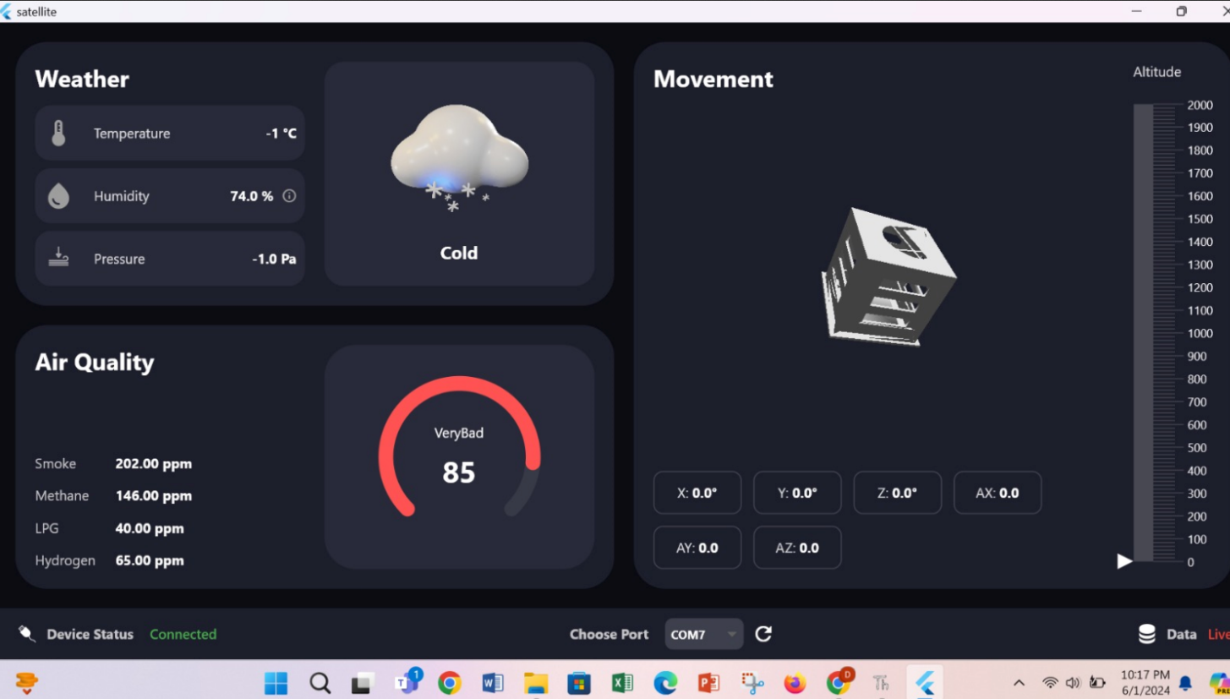

**Figure 3.2 OUTPUT AT INITIAL STAGE**

TheMQ -2 sensor, BMP-280 Sensor, I2 C, MPU 6050 Sensor are used to measure the pressure, humidity and hazardous gas level(smoke, methane, lpg , hydrogen) of the environment [1]. The information collected the sensors are stored in a SD Card which displays the collected information in an application that can be viewed in a mobile phone or other devices.

**3.2 WORKING**

The weather station functions by utilizing a custom-designed PCB board to integrate the Raspberry Pi Pico along with several sensors, including the MQ-2 for gas detection, BMP-280 for measuring temperature, pressure, and altitude, and the MPU-6050 for motion tracking and orientation sensing. [2] The sensors are connected to the Raspberry Pi Pico via GPIO pins, with communication facilitated primarily through the I2C protocol. Programming for the weather station is done using Thonny, where code is written in Micropython to initialize sensor communication, read data from the sensors, and process it accordingly. We have employed libraries such as `uos`, `SDCard`, and `MPU6050` for sensor interfacing and data manipulation.

The Raspberry Pi Pico periodically collects sensor data, which is then stored onto a microSD card for logging purposes. [3] Once operational, the weather station continuously monitors environmental conditions, providing valuable data for analysis or display.

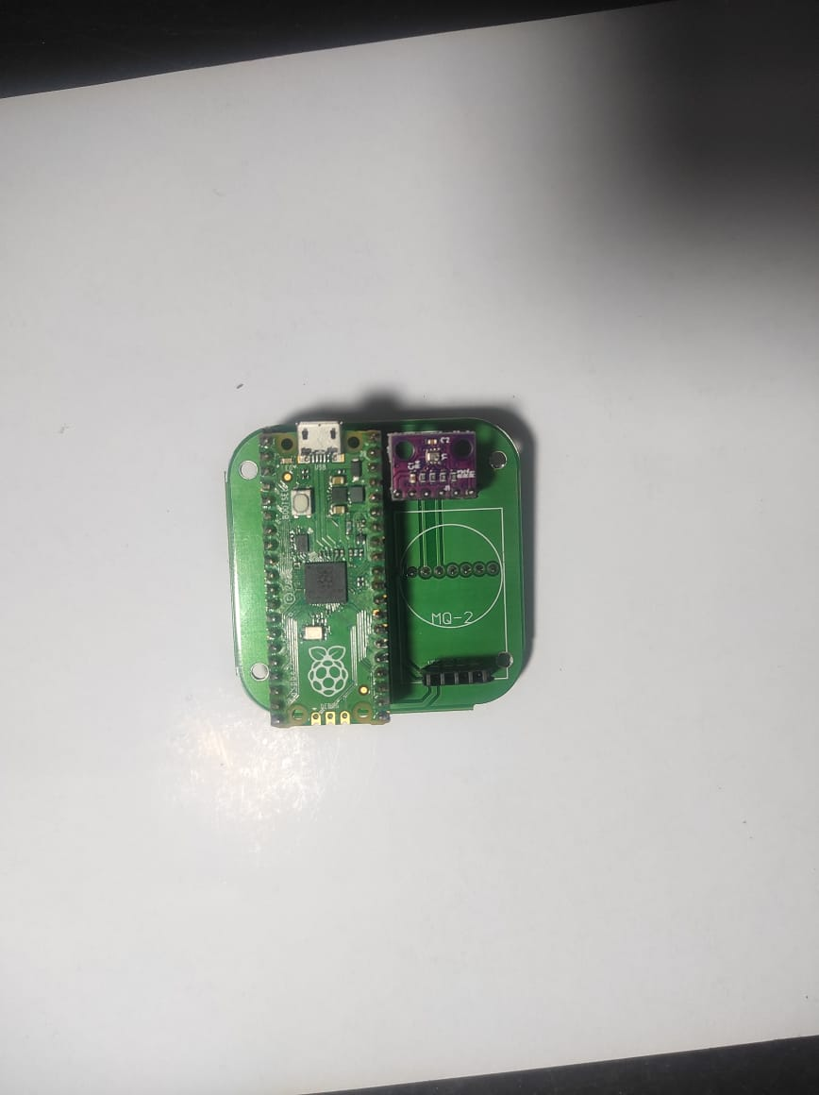

**Figure 3.3 SECOND STAGE**

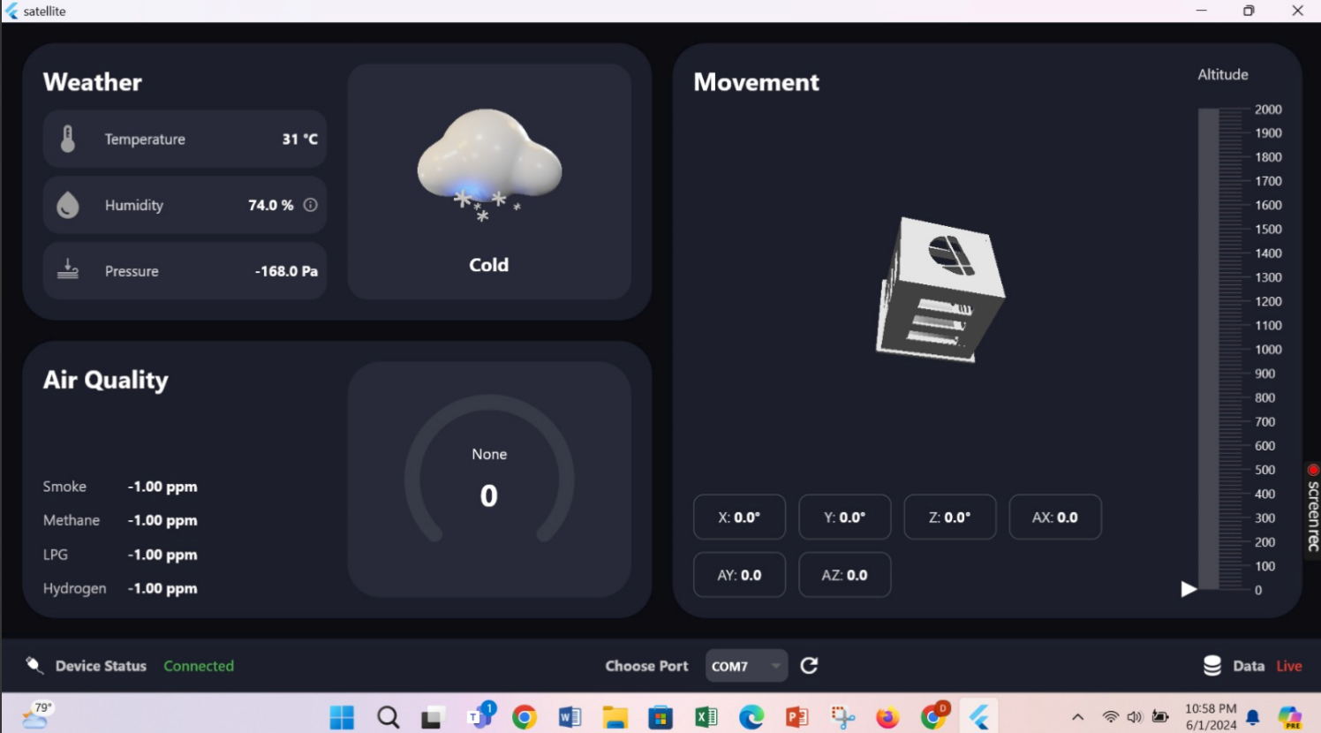

**Figure 3.4 OUTPUT AT SECOND STAGE**

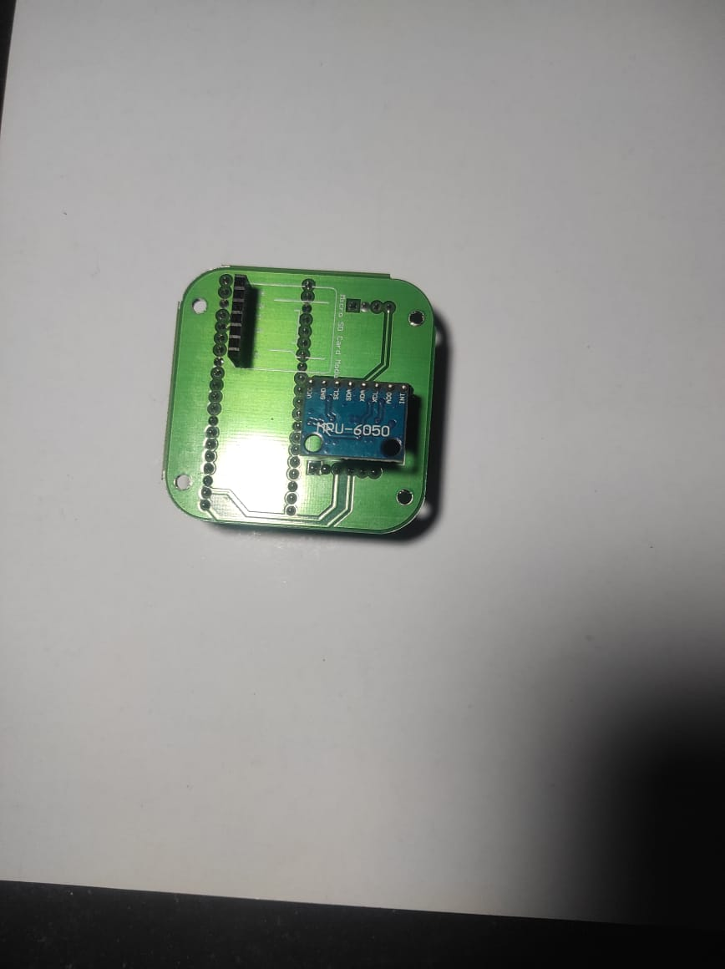

**Figure 3.5 THIRD STAGE**

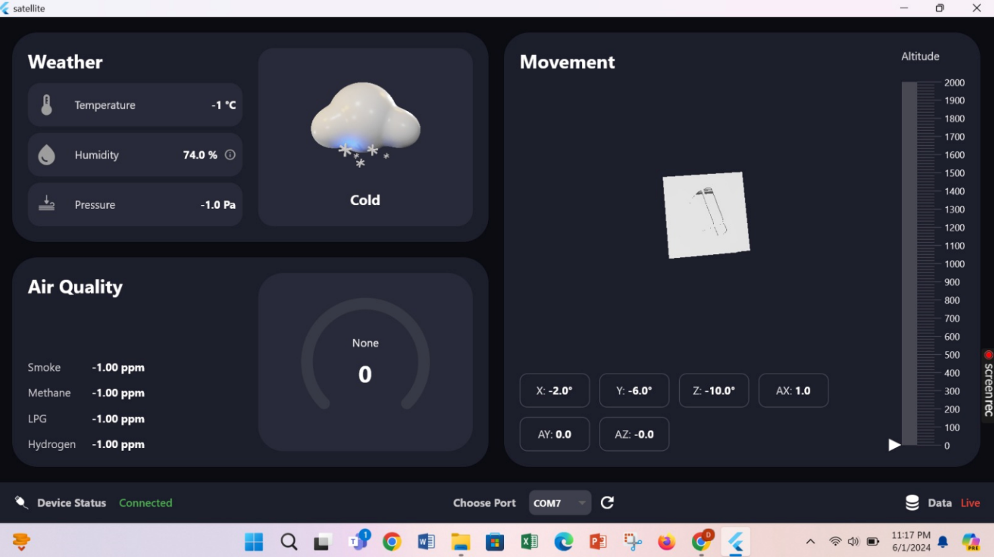

**Figure 3.6 OUTPUT AT THIRD STAGE**

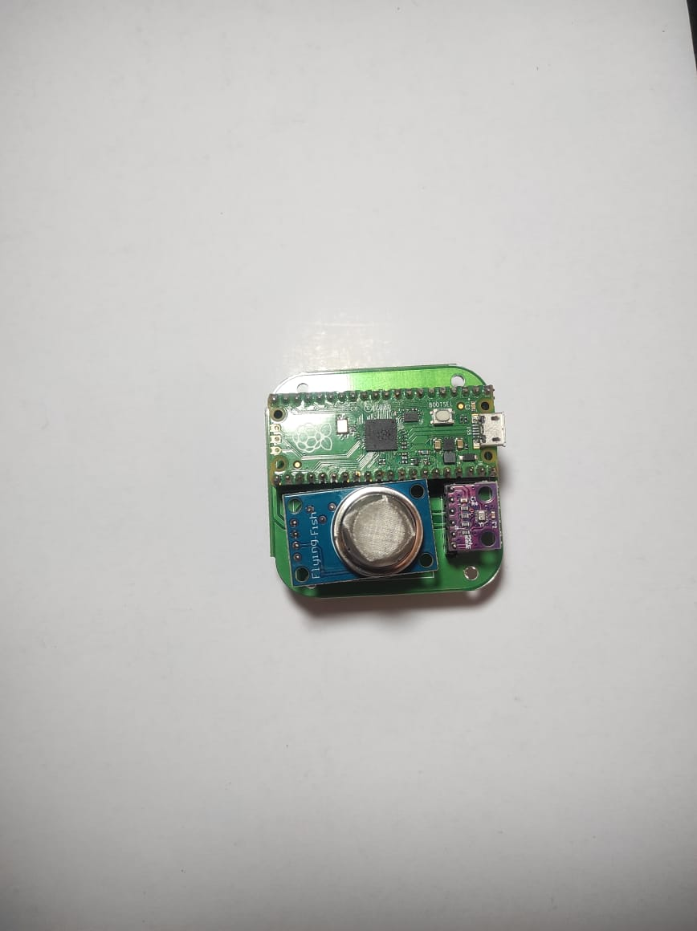 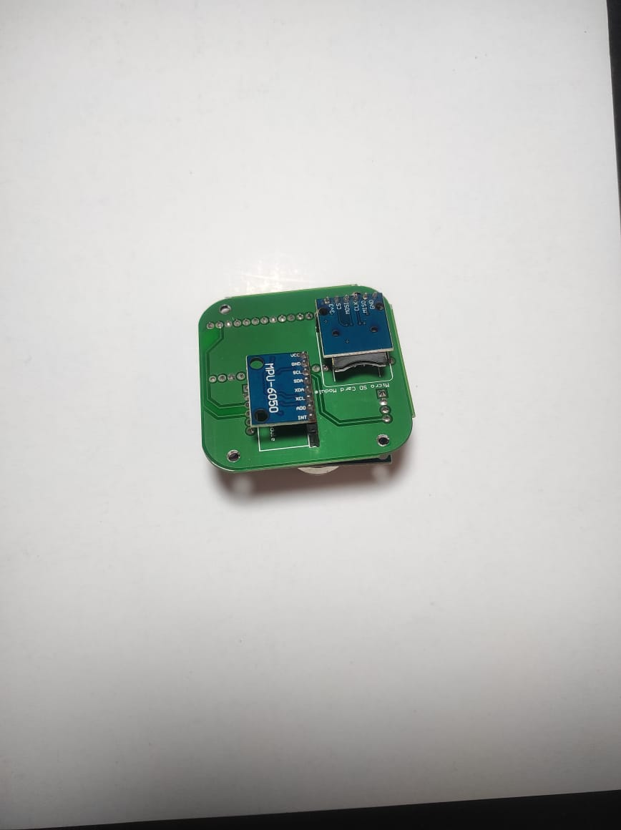

**Figure 3.7 FINAL STAGE**

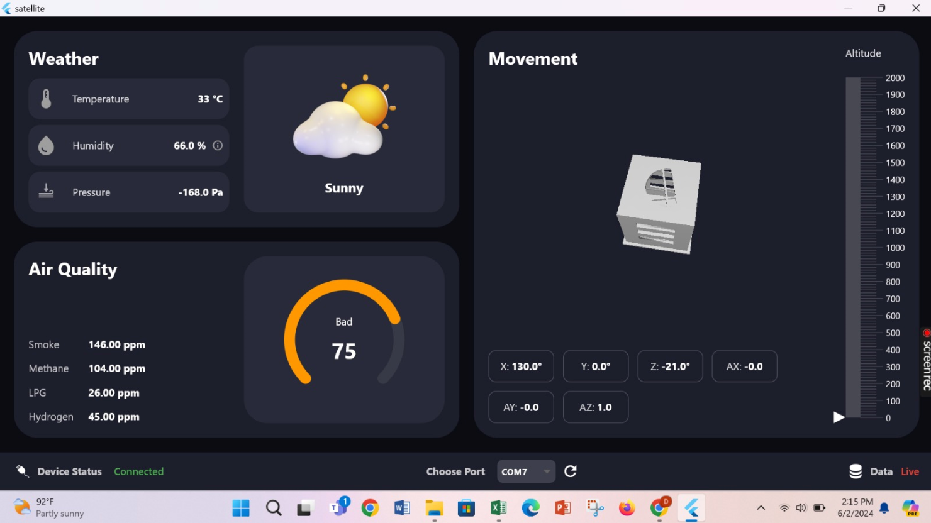

**Figure 3.8 FINAL OUTPUT**

**3.4 ADVANTAGES**

1. Cheap and affordable
2. Versatile
3. Accuracy and precise data collection

**CHAPTER 4**

**COMPONENT DESCRPITION**

* 1. **PCB BOARD:**

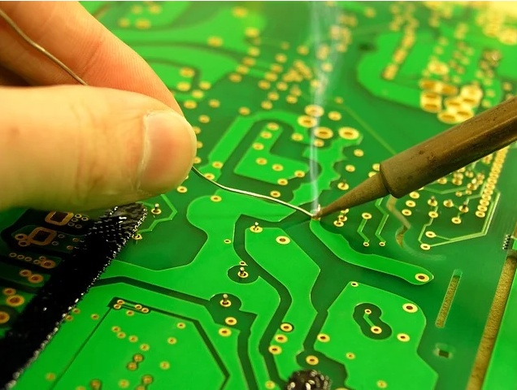

**Figure 4.1 PCB BOARD**

A printed circuit board (PCB) is an electronic assembly that uses copper conductors to create electrical connections between components. PCBs also provide mechanical support for electronic components so that a device can be mounted in an enclosure. All PCBs are built from alternating layers of conductive copper with layers of electrically insulating material. Conductive features on printed circuit boards include copper traces, pads, and conductive planes. The mechanical structure is made up of the insulating material laminated between the layers of conductors. [4] The overall structure is plated and covered with a non-conductive solder mask, and silk screen is printed on top of the solder mask to provide a legend for electronic components. After these fabrication steps are completed, the bare board is sent into printed circuit board assembly, where components are soldered to the board and the PCBA can be tested.

Printed circuit boards are often referred to as PWB, and also have many people called **PCB substrate**. [6] Since the printed circuit board is not a general terminal product, the definition of the name is slightly confusing. For example, the motherboard for personal computers is called the mainboard, and cannot be directly called the circuit board. Although there are circuit boards in the motherboard, They are not the same, so when evaluating the industry, the two are related but cannot be said to be the same. [7] Another example: because there are integrated circuit components mounted on the circuit board, the news media call it an IC board, but in fact, it is not equivalent to a printed circuit board. We usually say that the printed circuit board refers to the bare board- that the circuit board without upper components. [14]

According to the number of electronic board layers, it can be divided into single-sided, double-layer, four-layer, six-layer, and other multilayer circuit boards. And continue to develop in the direction of high precision, high density, and high reliability. Continuously shrinking volume, reducing costs, and improving performance have enabled printed circuit boards to maintain strong vitality in the development of future electronic products. [5]

* 1. **RASPERRY PI PICO:**

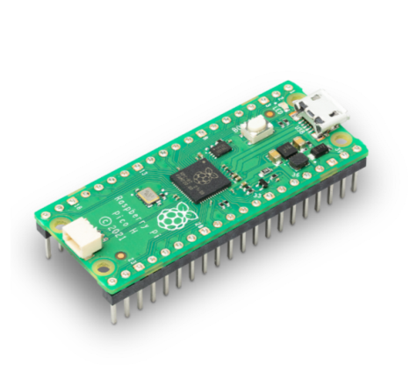

**Figure 4.2 RASPBERRY PI PICO**

The Raspberry Pi Pico is a microcontroller board developed by the Raspberry Pi Foundation. It's notable for being the first microcontroller-class product from Raspberry Pi, which is traditionally known for its single-board computers (SBCs).[6]The Pico is built around the RP2040 microcontroller chip, which was designed by Raspberry Pi themselves.

Here are some key features of the Raspberry Pi Pico:

1. RP2040 Microcontroller: The heart of the Pico is the RP2040 microcontroller, which features a dual-core Arm Cortex-M0+ processor running at up to 133MHz.

2. Memory: It has 264KB of RAM and supports external flash memory via QSPI (Quad Serial Peripheral Interface).

3. GPIO Pins: The Pico offers 26 GPIO pins, which can be programmed for various purposes like digital input/output, PWM (Pulse Width Modulation), SPI (Serial Peripheral Interface), I2C (Inter-Integrated Circuit), UART (Universal Asynchronous Receiver-Transmitter), and more. [13]

4. Micro USB Connectivity: It can be powered and programmed via micro USB, which also serves as a UART for serial communication.

5. Low Power Consumption: The RP2040 chip is designed for low power consumption, making it suitable for battery-powered applications.

6. Programmability: The Pico can be programmed using various programming languages, including MicroPython, CircuitPython, C/C++, and even assembly language.

7. Price: One of the most attractive features of the Raspberry Pi Pico is its affordability. [12] It's priced very competitively, making it accessible for hobbyists, educators, and professionals alike.

The Raspberry Pi Pico has gained significant popularity in the maker community due to its versatility, ease of use, and the vast ecosystem of libraries and resources available for programming and interfacing with it.

* 1. **MQ -2 SENSOR:**

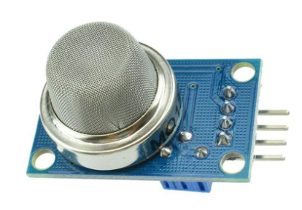

**Figure 4.3 MQ-2 SENSOR**

The MQ-2 sensor is a gas sensor that can detect a variety of gases such as methane, propane, hydrogen, smoke, and carbon monoxide (CO). [12] It's often used in projects related to gas leakage detection, fire detection systems, and air quality monitoring. The MQ-2 sensor has high sensitivity to a range of combustible gases and smoke. It operates on the principle of resistance changes in response to the presence of specific gases in the environment. [14]

The sensor provides an analog output voltage that varies with the concentration of the detected gas. This analog signal can be read by a microcontroller or an analog-to-digital converter (ADC).The MQ-2 sensor contains a built-in heater element that is used to heat the sensing element inside the sensor. This heating process is necessary for the sensor to operate accurately and requires a warm-up time before readings can be considered stable.

The sensor may require calibration to ensure accurate readings, especially when used in different environmental conditions or to detect specific gases. Calibration involves exposing the sensor to known concentrations of gases and adjusting the readings accordingly. [3]The typical operating voltage for the MQ-2 sensor is around 5V DC. It can be easily interfaced with microcontrollers like Arduino, Raspberry Pi, or other development boards. Reading the analog output voltage from the sensor allows you to determine the concentration of the detected gas.

* 1. **BMP-280 SENSOR:**

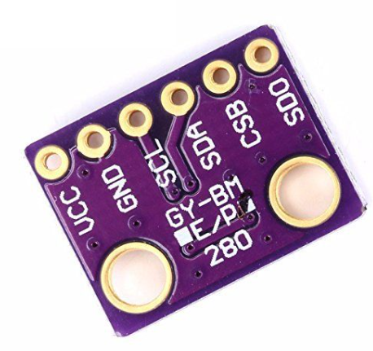

**Figure 4.4 BMP-280 SENSOR**

The BMP280 is an absolute barometric pressure sensor, which is especially feasible for mobile applications. Its small dimensions and its low power consumption allow for the implementation in battery-powered devices such as mobile phones, GPS modules or watches. The BMP280 is based on Bosch’s proven piezo-resistive pressure sensor technology featuring high accuracy and linearity as well as long-term stability and high EMC robustness. Numerous device operation options guarantee for highest flexibility. [7]The device is optimized in terms of power consumption, resolution and filter performance.

* 1. **I2 C:**

The Inter-Integrated Circuit (I2C) protocol is a widely utilized serial communication standard. It simplifies connectivity between integrated circuits on a circuit board or between microcontrollers and peripheral devices, like sensors or memory chips. With just two wires—Serial Data Line (SDA) and Serial Clock Line (SCL)—I2C facilitates straightforward bus connections. Devices on the bus adhere to a master-slave architecture, where one or more master devices orchestrate communication and multiple slave devices respond to commands. Each device possesses a unique address, allowing precise communication. The protocol operates synchronously, with data transferred in 8-bit bytes, accompanied by start and stop conditions. [9]Acknowledgment signals from receiving devices ensure data integrity. I2C's versatility, low pin count, and ease of implementation have made it a cornerstone of embedded systems and IoT applications.

* 1. **MPU 6050 SENSOR:**

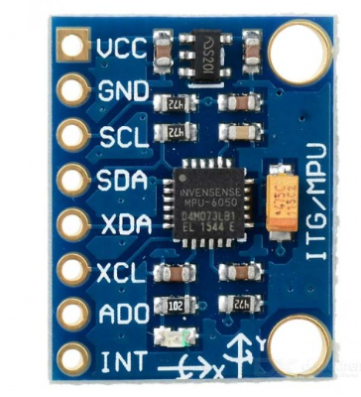

**Figure 4.5 MPU 6050 SENSOR**

The MPU-6050 sensor, a compact and versatile component, combines a 3-axis gyroscope with a 3-axis accelerometer, providing a comprehensive solution for motion tracking and orientation sensing. With six degrees of freedom, it accurately measures angular velocity and acceleration along multiple axes, enabling precise detection of rotational and linear movements in three-dimensional space. Utilizing a digital interface like I2C or SPI, the MPU-6050 communicates seamlessly with microcontrollers or other devices, making it easy to integrate into various applications. [11]

Some versions of the sensor even feature a built-in Digital Motion Processor (DMP), offloading complex sensor fusion calculations for enhanced performance. Its low power consumption and wide range of motion processing algorithms make it suitable for diverse applications such as gaming, virtual reality, robotics, and wearable devices. Overall, the MPU-6050 sensor stands as a fundamental component in motion-based systems, offering accurate and reliable motion tracking capabilities in a compact and cost-effective package.

* 1. **MICROSD CARD :**

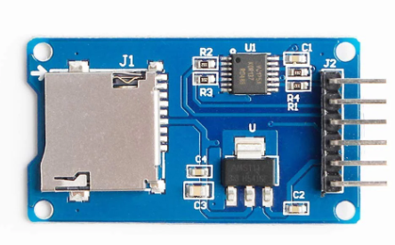

**Figure 4.6 MICROSD CARD**

A microSD card is a compact and versatile form of removable storage commonly used in various electronic devices, including smart phones, tablets, digital cameras, and IoT devices. Despite its small size, a microSD card can offer significant storage capacity, ranging from a few gigabytes to multiple terabytes in newer models. [10] Its diminutive form factor makes it ideal for devices where space is limited or where a smaller footprint is desired. MicroSD cards typically use flash memory technology, which provides fast read and write speeds, making them suitable for storing large amounts of data such as photos, videos, music, and applications.

Additionally, microSD cards are often used for transferring data between devices, thanks to their widespread compatibility and plug-and-play nature. Overall, microSD cards offer a convenient and portable solution for storing and transferring data, making them indispensable in today's digital world.

* 1. **SIMULATION TOOL –THONNY**

Thonny," an Integrated Development Environment (IDE) primarily focused on Python programming. Thonny is designed to provide a user-friendly environment for writing, debugging, and executing Python code. Its interface is clean and intuitive, making it particularly suitable for beginners learning Python programming. Thonny offers several features to support the coding process. It includes a built-in Python interpreter, allowing users to write and execute Python code directly within the IDE.



**Figure 4.7 THONNY**

One notable aspect of Thonny is its simplicity. The IDE strives to minimize complexity, providing only essential features needed for Python development. This approach makes Thonny lightweight and easy to use, ideal for educational settings or individuals new to programming.

**CHAPTER 5**

**CONCLUSION AND FUTURE SCOPE**

**5.1 CONCLUSION**

The proposed project has been successfully tested and has shown quick response to the hazardous gases level. We can conclude that this device can be used by farmers to monitor air quality and detect the presence of pollutants that may affect crop health and crop productivity. However, depending on the environment, it can change according to the requirements.

**5.2 FUTURE SCOPE**

The system can provide individuals with real-time alerts and recommendations to minimize exposure to hazardous gases during periods of poor air quality, reducing the risk of respiratory illnesses and other health effects. Urban planners and developers can leverage the data provided by the system to design and implement sustainable development projects that prioritize clean air and public health in urban areas. [5] The system can contribute to early warning systems for environmental disasters such as wildfires and industrial accidents by detecting changes in air quality and providing timely alerts to emergency responders and affected communities. [8] Farmers can use the system to monitor air quality and detect the presence of pollutants that may affect crop health and productivity. Real-time alerts can prompt farmers to implement mitigation strategies such as adjusting irrigation schedules, applying protective coatings to crops, or deploying air filtration systems in greenhouses**.**

**CHAPTER 6**

**RESULT**

The Smart Satellite Weather Station can detect the weather in the particular area it is placed in. It can produce the level of hazardous particles in the surrounding along with the temperature, humidity and pressure. This system can also be used in gas leak or other man-made disaster related to atmosphere or climate to detect gas levels. The Smart Satellite Weather Station is a versatile and advanced system designed to monitor and analyze various atmospheric conditions and environmental factors. It measures ambient temperature, humidity levels, and atmospheric pressure to provide comprehensive weather monitoring. Additionally, it detects hazardous particles in the air, such as PM2.5 and PM10, indicating air quality. The system is also capable of identifying dangerous gases, aiding in the detection of gas leaks and other man-made atmospheric disasters. This makes it valuable for environmental monitoring, health and safety protection, and disaster management, ensuring timely detection and response to both natural and man-made hazards. This versatility makes the Smart Satellite Weather Station an invaluable tool for a wide range of applications, including environmental monitoring, where it helps track local climate conditions and pollutant levels; health and safety protection, by alerting to hazardous air quality; and disaster management, by facilitating early detection and response to both natural and anthropogenic hazards. Overall, this system plays a critical role in maintaining environmental safety and public health by providing timely and accurate data for informed decision-making.

**APPENDIX:**

import machine

import utime

import uos

from chittiSat.mq2 import MQ2

from chittiSat.gyro import MPU6050

from chittiSat.assistant import *

from chittiSat.pressure import *

#i2c configuration

i2c=machine.I2C (0,scl=machine.Pin (1),sda=machine.Pin(0))

devices=i2c.scan()

if devices:

print (devices)

#mq2

sensor=MQ2 (pinData=26)

sensor. calibrate ()

#gyro

mpu6050=MPU6050(i2c)

#pressure

bmp280=BMP280(i2c)

calibrate.pressure(bmp280)

spi = machine.SPI(1, sck=machine.Pin(14), mosi=machine.Pin(15), miso=machine.Pin(12))

cs = machine.Pin(13, machine.Pin.OUT)

sd = SDCard(spi, cs)

uos.mount(sd, '/sd')

print ("SD card connected")

print (uos.listdir('/sd'))

timestamp = time.localtime()

filename = "/sd/data_{:04d}{:02d}{:02d}_{:02d}{:02d}{:02d}.csv".format(

timestamp [0], timestamp[1], timestamp[2],

timestamp [3], timestamp[4], timestamp[5]

)

Print (f"Creating file: {filename}")

with open(filename, "w") as f:

f.write ("Time")

f.write (",")

f.write ("Pressure")

f.write (",")

f.write ("temperature")

f.write (",")

f.write ("Smoke")

f.write (",")

f.write ("LPG")

f.write (",")

f.write ("Methane")

f.write (",")

f.write ("Hydrogen")

f.write (",")

f.write ("Ax")

f.write (",")

f.write ("Ay")

f.write (",")

f.write("Az")

f.write(",")

f.write("Gx")

f.write(",")

f.write("Gy")

f.write(",")

f.write ("Gz")

f.write(",")

f.write ("\n")

while True:

t=time.ticks_ms()/1000

Pressure=bmp280.pressure

temperature=bmp280.temperature

GAS=sensor.readLPG()

Smoke=sensor.readSmoke()

Methane=sensor.readMethane()

Hydrogen=sensor.readHydrogen()

ax=round(mpu6050.accel.x,2)

ay=round(mpu6050.accel.y,2)

az=round(mpu6050.accel.z,2)

gx=round(mpu6050.gyro.x,2)

gy=round(mpu6050.gyro.y,2)

gz=round(mpu6050.gyro.z,2)

f.write(str(t))

f.write(",")

f.write(str(Pressure))

f.write(",")

f.write(str(temperature))

f.write(",")

f.write(str(Smoke))

f.write(",")

f.write(str(GAS))

f.write(",")

f.write(str(Methane))

f.write(",")

f.write(str(Hydrogen))

f.write(",")

f.write(str(ax))

f.write(",")

f.write(str(ay))

f.write(",")

f.write(str(az))

f.write(",")

f.write(str(gx))

f.write(",")

f.write(str(gy))

f.write(",")

f.write(str(gz))

f.write(",")

f.write("\n")

f.flush()

print("our data saved")

**REFERENCES**

[1] Al-Ali A, Zualkernan I, and Aloul F, “A mobile gprs-sensors array for air ___pollution monitoring,” IEEE Sensors Journal, vol. 10, no. 10.

[2] Aamer H, Mumtaz R, Anwar H, and Poslad S, “A very low cost, open, ___wireless, internet of things (iot) air quality monitoring platform,” in 2018 , 15th ___International Conference on Smart Cities: Improving Quality of Life Using ICT ___& IoT (HONET-ICT). IEEE, 2018.

[3] Bas E, Indoor air quality: A guide for facility managers. CRC Press, 2003.

[4] Boscolo S and Mangiavacchi C, “Pollution dynamic monitoring system for ___city air quality control,” in IMTC/98 Conference Proceedings. IEEE +++Instrumentation and Measurement Technology Conference. Where ___Instrumentation is Going (Cat. No. 98CH36222), vol. 1. IEEE, 1998

[5] Halvorsen H P, Grytten O A, Svendsen M V, and Mylvaganam S, ___“Environmental monitoring with focus on emissions using iot platform for ___mobile alert,” in 2018 28th EAEEIE Annual Conference (EAEEIE). IEEE, ___2018.

[6] Hern´andez-Morales C A, Luna-Rivera J, and Perez-Jimenez R, “Design and ___deployment of a practical iot-based monitoring system for protected ___cultivations,” Computer Communications, 2022.

[7] Kularatna.N and Sudantha.B, “An environmental air pollution monitoring ____system based on the ieee 1451 standard for low cost requirements,” IEEE ____Sensors Journal, vol. 8, no. 4, 2008.

[8] Math. R. K and Dharwadkar. N. M, “Iot based low-cost weather station and ___monitoring system for precision agriculture in India,” in 2018 2nd International ___Conference on I-SMAC (IoT in Social, Mobile, Analytics and Cloud)(I-___SMAC) I-SMAC (IoT in Social, Mobile, Analytics and Cloud)(I-SMAC), 2018 ___2nd International Conference on. IEEE, 2018

[9] Mohapatra D and Subudhi B, “Development of a cost effective iot- based ___weather monitoring system,” IEEE Consumer Electronics Magazine, 2022.

[10] Raipure. S and Mehetre. D, “Wireless sensor network based pollution _____monitoring system in metropolitan cities,” in 2015 International Conference _____on Communications and Signal Processing (ICCSP). IEEE, 2015.

[11] Rajapaksha.T.T, Alexander .A, Fernando. L, Than. A, and Nguyen. H. L, ____“Real-time weather monitoring and iot-based palmtop device for smart ____agriculture,” SN Computer Science, vol. 3, no. 1, 2022.

[12] Rao.V and Prema.K, “Internet-of-things based smart temperature monitoring ____system,” in 2018 3rd IEEE International Conference on Recent Trends in ____Electronics, Information & Communication Technology (RTEICT). IEEE, ____2018

[13] Won. J. K, Park. Y .M,Koo S. J, and Kim. H, “Design of air pollution ___monitoring system using zigbee networks for ubiquitous-city,” in 2007 ___International Conference on Convergence Information Technology (ICCIT ___2007). IEEE, 2007